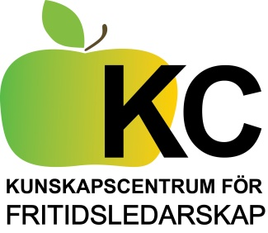 | Knowledge Centre  for open youth work

KC is short for “Knowledge Centre for leadership/youth work in open youth clubs.The aim of this centre is to develop and evaluate methods and leadership for work in ‘open activity’ at youth clubs and recreation centres. We work mainly within the field of leisure – with a promotive approach and empowerment (not social work).
To achieve this purpose we use different methods for development, exchange of best practice and peer learning. We also keep up with current research, arranging workshops and seminaries and we also start different projects together to develop the work at the youth centres.

Recent Projects:
- Work with projects A guide how to develop and run a project
- Open Club for ”older teenagers (Seminars and network)
- Observation of quality in open youth work- education of observers and a method for observing youth work
- Methods of promotive youth work – a model for analyses and development of a promotive approach to youth work, based on Aron Antonovskys theory
- Youth work in social media- development of methods and also
- Yowomo 2.0 - an EU/Leonardoproject with descriptions of competences for youth work in social media ( see webbpage)
- Ethics for youth work within the field of leisure
- Outreach youth work – a method to reach new groups, to collaborate with NGO:s and to create new forms of and widening the supply of activities in the area.
KC is an regional collaboration 14 municipalities around Stockholm and Skarpnäcks Folk High School/The Youth Work education
We are interested in international exchange, contacts and network. Don´t hesitate to contact us through our coordinator!
Diana Pettersson Svenneke
Coordinator
Phone:+46(0)8 6831849 or
+46 (0)70-6996453
Kunskapscentrum för fritidsledarskap
c/o Skarpnäcks folkhögskola
Horisontv. 26
S-128 34 Skarpnäck, Sweden

diana@fritidsledarskap.se www.fritidsledarskap.se

